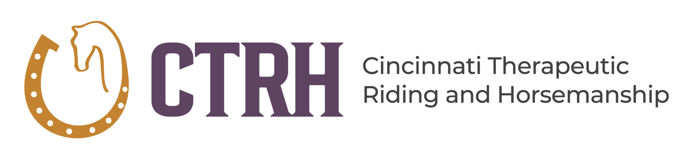

Recreational Riding Class Registration – Session 5
1342 U.S. Highway 50, Milford, Ohio 45150
Phone: 513-831-7050 | caroline.ferguson@ctrhohio.org
www.ctrhohio.org

IMPORTANT INFORMATION
- Session Dates: September 27 – November 21, 2026
- New Riders: Must schedule a pre-enrollment visit prior to registration
- Call: 513-831-7050 for scheduling or questions
- Class Placement: First come, first served
- Payment: Session fees are due no later than one week prior to the start of the session.

PARTICIPANT INFORMATION
Rider Name: _______________________________________________
Age (minimum 5 years): ___________
Height: ___________ Weight: ___________

Weight Guidelines
- 175 lbs. max for balanced rider
- 150 lbs. max for unbalanced rider*
*A balanced rider demonstrates flexibility, strength, posture, and the ability to adjust weight distribution on the horse as needed. Final determination is made by instructor/therapist discretion.

SESSION FEES
Session 4 Fee: $540.00 ($67.50 per week)
Payment is required in full regardless of known absences.
Example: If you miss 2 classes for vacation, the full session fee still applies.
Session fees are due no later than one week prior to the start of the session.

PROGRAM INFORMATION

Adaptive Recreational Riding
Group lessons led by PATH Intl. certified instructors.
Each rider is supported by a horse leader and up to two side walkers.
Minimum 2 riders per class required.

Intermediate Riding
For riders who can independently rein, circle, and halt.
Classes of 2–5 riders with PATH Intl. certified instructors.
Typically includes a horse leader only.
Requires prior participation or instructor approval.

CLASS SCHEDULE – SESSION 4

Recreational Riding
Day | Time | Availability
Monday | 11:00 AM – 12:00 PM | 4 spots
Monday | 4:45 – 5:45 PM | 4 spots
Tuesday | 5:45 – 6:45 PM | 4 spots
Wednesday | 5:45 – 6:45 PM | 4 spots
Thursday | 5:45 – 6:45 PM | 4 spots
Saturday | (varies if applicable) | 4 spots

Intermediate Riding
Day | Time | Availability
Monday | 7:00 – 8:00 PM | 4 spots
Tuesday | 7:00 – 8:00 PM | 4 spots
Wednesday | 7:00 – 8:00 PM | 4 spots
Thursday | 7:00 – 8:00 PM | 4 spots

CLASS SELECTION
Please review the schedule and select:
First Choice: ___________________________________________
Second Choice: __________________________________________
Dates Rider Will Not Attend (if known): __________________________________________

REGISTRATION INFORMATION
Current riders may register via fax, mail, or email.
Payment options:
- ☐ Check (mail)
- ☐ Cash
- ☐ Credit/Debit Card (Square invoice emailed)
A 5% convenience fee applies to credit/debit card payments.
Once payment is received, a confirmation email will include:
- Class day and time
- Instructor assignment
- Payment receipt
Third Party Payer (CCDD, etc.): __________________________________________
How will you pay?
☐ Check / Cash
☐ Credit Card (invoice emailed, 5% fee applies)

Has the rider's medical status changed?
☐ No
☐ Yes → Please explain: _______________________________________

CONTACT INFORMATION
Parent/Caregiver Name: ____________________________________
Email (print clearly): ______________________________________
Phone (Cell/Home/Work): ___________________________________
Emergency Contact Name & Phone: ___________________________________

ATTENDANCE POLICY
- Each rider receives 1 excused absence credit per session
- 24-hour notice required for credit eligibility
- Credits apply to next session (no cash refunds)
- Late arrival over 15 minutes = No Show

DRESS CODE & HEALTH POLICY
- Long pants required (no shorts or capris)
- Closed-toe, secure footwear only (no Crocs or sandals)
- Must be fever/vomiting free for 24 hours before returning

WEATHER & CANCELLATION POLICY
Classes may be canceled due to:
- Milford School District closure
- Extreme heat/humidity
- Temperatures below 20°F
- Thunderstorms, lightning, high winds
- Unsafe facility conditions (snow/ice)
Notifications will be made via phone, email, or Facebook as soon as possible.

HOLIDAYS & BREAKS (2026 CLOSURES)
- Winter Break: Jan 1 – Jan 19
- President’s Day: Feb 16
- Break Week: Mar 15 – Mar 21
- Good Friday: Apr 3
- Break Week: May 17 – May 23
- Memorial Day: May 25
- Juneteenth: June 19
- Independence Day: July 3 – 4
- Break Week: July 19 – July 25
- Labor Day: Sept 7
- Break Week: Sept 20 – Sept 26
- Columbus Day: Oct 12
- Break Week: Nov 22 – Nov 28
- Winter Break: Dec 20 – Jan 18

